Ringing in Lockdown
When will we be worshiping together again in St Oswald’s? Although Harvey and others are doing fantastic work online, this question must be on everybody’s lips. We don’t know, but one thing is quite clear, bell ringing will not be able to resume as soon as the church building is opened because of the issues of access and safe distancing. Ringing is not simply a question of tugging on ropes but requires many different skills, so our ringers are trying to maintain some of these during lockdown.
With help from our American cousins ( See https://cccbr.org.uk/2020/05/31/bbc-news-item-on-bellringing-during-lockdown/ ) we now meet up for our Thursday practice on the internet with pressing keys replacing pulling ropes. We use the new software, developed during lockdown, called ‘Ringing Room’ which looks like this 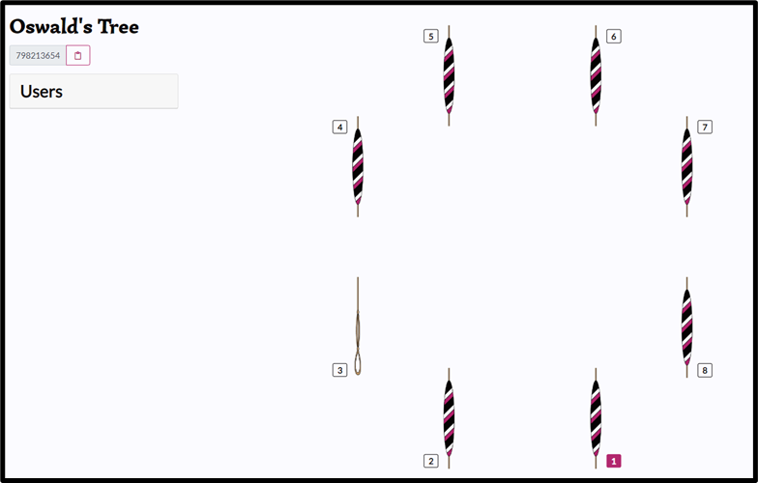 .
Each ringer, safely isolating at their computer, is assigned a bell which will ring each time they press a key and the internet ensures that all the other ringers will see and hear the result on their computers. This enables us to remotely join up and refresh our memories of the methods used to change the order of the bells. It also enables us to try to ring in a rhythmic fashion but sometime the variable speed of the internet can make this difficult! We also hold a simultaneous Zoom meeting to allow discussion of what we are going to try next and discuss problems.
As you can see we have our own virtual tower call “Oswald’s Tree” and you can see what our screens look like and hear our efforts by logging onto https://ringingroom.com/798213654/Oswald's%20Tree/listen . This does not enable you to join the Zoom meeting so you might encounter long periods of inaction whilst we discuss matters. We try to ring between 6:45 and 7:45 on Thursday evenings but you might find it being used at other times. Do have a look.
Although this helps us a little, we are all eager for the time we can meet up properly in the tower. If this inspires you to find out more about ringing there is lots of information available at https://cccbr.org.uk/ and ,when we are allowed back, you might like to consider learning to ring yourself.
Richard Major

