NEWS

Material required in the office for the February magazine TODAY Sunday 11 January. Please could all organisations and groups in the churches try to send some news in or email dianedawson15@gmail.com

PLACE OF WELCOME Tuesdays at 10.30 - 12.30 in the Parish Centre. Everyone is welcome.

FOOD BANK: Urgently requires tinned ham/spam/corned beef, baked beans, spaghetti hoops, tea and coffee, jams and spreads, tomato sauce and mayonnaise, pasta and rice 500g, dog and cat food.

PARISH NEWS – A reminder that subscriptions for the forthcoming year are due by the end of January - £5 for the twelve months or 50p each month. There is no increase on last year’s price.

ST OSWALD’ BOOK CLUB meet in Parish Centre on Wednesday 21st January at 7.30 p.m. We’ll be reading and discussing our new book - ‘Praying by Heart, The Lord’s Prayer for Everyone’ by Stephen Cottrell. All are welcome to join us for coffee, cake and lively discussion.

9 o’clock Morning Prayer is streamed on the Facebook page on Wednesday and Friday
mornings.
Sunday worship on the You Tube page

CHURCH CALENDAR

MONDAY 12th JANUARY

14.00 Barry Johnson funeral at Oswestry
Cemetery Chapel followed by interment.

TUESDAY 13th JANUARY

10.30 Place of Welcome in Parish Centre

WEDNESDAY 14th JANUARY

08.30 Oswestry School Assembly - 0940
09.00 Morning Prayer (online)
10.00 Under 5’s Playgroup - Parish Centre
10.30 Christ Church PCC in Rhydycroesau
village hall

THURSDAY 15th JANUARY

10.30 Holy Communion (BCP)
14.00 Mission & Ministry Team meeting
19.30 Bell ringing practice - 2100

FRIDAY 16th JANUARY

09.00 Morning Prayer (online)
19.15 Full Choir - 20.30
20.30 Choral Scholars and Adults - 21.00

The Rev Harvey Gibbons
stoswald.office@gmail.com
http://www.stoswaldsoswestry.org.uk
or follow us on Facebook at:
www.facebook.com/stoswaldsoswestry

THE PARISH CHURCH OF
ST. OSWALD
KING & MARTYR

EPIPHANY 1
(The Baptism of Christ)
11th January 2026

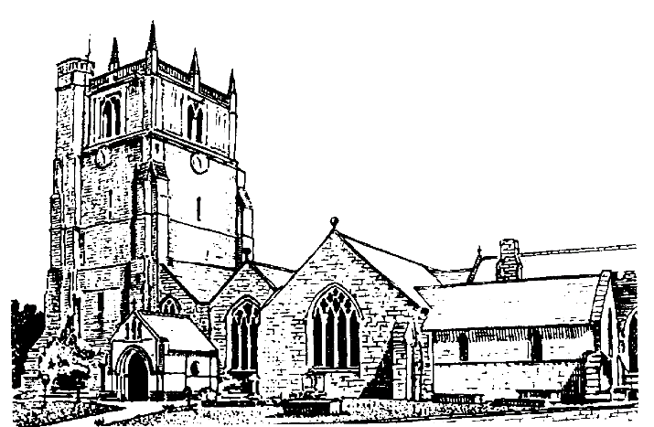

Lord of all life and power, who through the mighty resurrection of your Son overcame the old order of sin and death to make all things new in him: grant that we, being dead to sin and alive to you in Jesus Christ, may reign with him in glory: to whom with you and the Holy Spirit be praise and honour, glory and might now and
in all eternity. Amen

Welcome to worship at St. Oswald’s. Please introduce yourself, especially if you are a visitor or newcomer.

09.30 Holy Communion at Christ Church Rhydycroesau
President: Rev. Harvey Gibbons

10.10 Prayers in St. Catherine’s Chapel

10.30 Parish Eucharist at St. Oswald’s
President: Fr. Phil Hughes

Setting: Archer - St. Albans Service

Processional Hymn: 49

The Collect:
Eternal Father, who at the baptism of Jesus revealed him to be your Son, anointing him with the Holy Spirit; grant to us, who are born again by water and the Spirit, that we may be faithful to our calling as your adopted children; through Jesus Christ your Son our Lord, who is alive and reigns with you, in the unity of the Holy Spirit, one God, now and for ever.

Readings:
Isaiah 42:1-9
The prophet’s vision of the Messiah, who will bring justice to the nations.

Psalm 29

Acts 10:34-43
Peter’s sermon to the Gentiles is the Christian story, from the preaching of John the Baptist to the resurrection and humankind’s eventual judgement. Peter emphasises that God has no favourites.

Gradual Hymn: 52

Gospel Matthew 3:13-end
Jesus is baptised at the beginning of his ministry, is publicly endorsed by God and receives the Holy Spirit.

Preacher: Rev. Keith Musson

For your prayers:

Those working to preserve the ceasefire between Israel and Hamas and those working towards peace between Ukraine and Russia.

Those adversely affected by the ongoing winter weather and everyone working to keep others safe

The sick and everyone involved in the medical professions, especially those working for the NHS and in residential and care homes.

The families and friends of William Benyon, Irmgard Willeck, Barry Johnson and everyone who has recently been bereaved.

Offertory Hymn: 54

Communion Hymn: 288 (omit v 3)

Anthem: Tomorrow shall be my dancing day - Trad.

The Post Communion Prayer:
Lord of all time and eternity, you opened the heavens and revealed yourself as Father, in the baptism of Jesus your beloved Son; by the power of your Spirit complete the heavenly work of our rebirth through the waters of the new creation; through Jesus Christ our Lord.

Recessional Hymn: 57

Organ Voluntary: Postlude from Epiphany Suite by Charles Callahan

Please join us for Coffee in the Parish Centre after the service today.

18.00 Epiphany Carol Service
Mrs. Jenifer Chippet-Williams & Rev. Harvey Gibbons

SUNDAY 18th January (Second Sunday of Epiphany)

08.00 Holy Communion
10.30 Parish Eucharist St. Oswald’s
18.00: Evensong

