NEWS

PLACE OF WELCOME: Mince Pies and Christmas Music session, with Haydn Jones at the piano, next Tuesday, 16th December, in the Parish Centre. Please come and join us. All are welcome.

FOOD BANK: Urgently requires tinned ham/spam/corned beef, baked beans, spaghetti hoops, tea and coffee, jams and spreads, tomato sauce and mayonnaise, pasta and rice 500g, dog and cat food.

Come and choose your favourite carols and join in the sing-along today 2.30 p.m. - 4 p.m. in Church. Mince pies, tea and coffee afterwards. All welcome.

HAYDN JONES will be playing the piano in the indoor market on Saturday December 20th from 10.30 am. Christmas carols and songs. Donations for the Debra charity.

ST OSWALD’S BOOK CLUB in Parish Centre on Wednesday 17th December at 19.30 reading ‘Five for Sorrow, Ten for Joy’ by J. Neville Ward

Run through of carols for the Christingle & Crib Service after this morning’s service.

Epiphany drinks on January 6th … drop in to the vicarage between 6pm and 8pm for a drink and a mince pie. All are most welcome

9 o’clock Morning Prayer is streamed on the Facebook page on Wednesday and Friday
mornings.
Sunday worship on the You Tube page

CHURCH CALENDAR

MONDAY 15th DECEMBER
17.00 Woodside School Christmas Concert
19.00. Vocations workshop meeting

TUESDAY 16th DECEMBER
10.30 Place of Welcome in Parish Centre

WEDNESDAY 17th DECEMBER
09.00 Morning Prayer (online)
10.00 Under 5’s Christmas Party
12.00 Advent Reflection in St. Catherine’s
14.00 Morda CE Primary School Christmas
Service
17.15 Girl Guides/Brownies in Parish Centre
19.30 St. Oswald’s book club in Parish Centre

THURSDAY 18th DECEMBER
08.00 Marches School Concert - 20.00
10.30 Holy Communion (BCP)
19.30 Bell ringing practice - 2100

FRIDAY 19th DECEMBER
09.00 Morning Prayer (online)
12.00 Funeral of Daphne Madden in church
followed by interment in Oswestry
Cemetery.
19.15 Full Choir - 20.30
20.30 Choral Scholars and Adults - 21.00

SATURDAY 20TH DECEMBER
08.30 Orthodox Divine Liturgy Service - 10.30
10.30 Haydn Jones playing Christmas Carols
and Songs - Indoor Market for Debra
Charity.

The Rev Harvey Gibbons
stoswald.office@gmail.com
http://www.stoswaldsoswestry.org.uk
or follow us on Facebook at:
www.facebook.com/stoswaldsoswestry

THE PARISH CHURCH OF
ST. OSWALD
KING & MARTYR

THIRD SUNDAY OF ADVENT
14th DECEMBER 2025

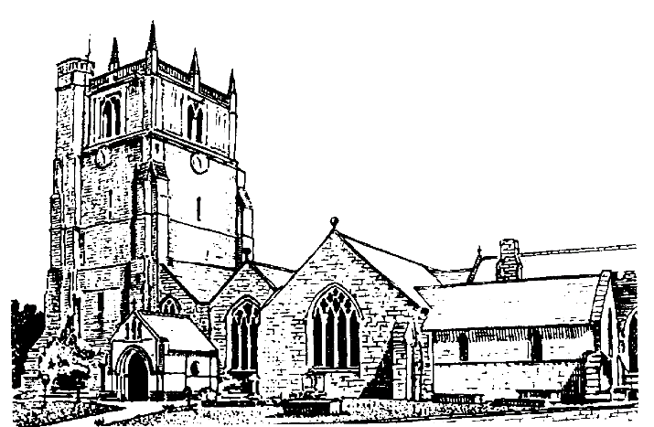

Lord of all life and power, who through the mighty resurrection of your Son overcame the old order of sin and death to make all things new in him: grant that we, being dead to sin and alive to you in Jesus Christ, may reign with him in glory: to whom with you and the Holy Spirit be praise and honour, glory and might now and
in all eternity. Amen

Welcome to worship at St. Oswald’s. Please introduce yourself, especially if you are a visitor or newcomer.

09.30 Holy Communion at Christ Church Rhydycroesau
President: Fr. Phil Hughes

10.10 Prayers in St. Catherine’s Chapel

10.30 Parish Eucharist at St. Oswald’s
President: Rev. Harvey Gibbons

Setting: Archer - St. Albans Service

Processional Hymn: 57

Kyries: Plainsong - De Angelis

The Collect:
O Lord Jesus Christ, who at your first coming sent your messenger to prepare your way before you: grant that the ministers and stewards of your mysteries may likewise so prepare and make ready your way by turning the hearts of the disobedient to the wisdom of the just, that at your second coming to judge the world we may be found an acceptable people in your sight; for you are alive and reign with the Father in the unity of the Holy Spirit, one God, now and for ever.

Readings:
Isaiah 35:1-10
The ransomed of the Lord will return to Zion. The desert will sing, those who are blind will see and deaf people will hear. Everlasting joy will be upon the ransomed of the Lord.

Psalm: 146 vv 4-10

James 5:7-10
We are called to show endurance, and to be patient until the coming of the Lord.

Gradual Hymn: 443

Gospel: Matthew 11:2-11
John sends word by his disciples, asking if Jesus is the one who is to come. Jesus tells them to go and say what they hear and see. Addressing the crowd, he explains that John is more than just a prophet.

Preacher: Rev. Keith Musson

For your prayers:

Those working to preserve the ceasefire between Israel and Hamas and those working towards peace between Ukraine and Russia.

The staff and young people of our schools as they prepare for the end of the Christmas term

The sick and everyone involved in the medical professions, especially those working for the NHS and in residential and care homes.

The families and friends of Daphne Madden, Sheila Lloyd and everyone who has recently been bereaved.

Offertory Hymn: 7

Communion Hymn: 275

Anthem: How beautiful upon the mountains – Sir John Stainer.

The Post Communion Prayer:
We give you thanks, O lord, for these heavenly gifts; kindle in us the fire of your Spirit that when your Christ comes again we may shine as lights before his face; who is alive and reigns now and for ever.

Recessional Hymn: 3

Organ Voluntary: Lift up your heads. By Michael Praetorius arr. By Paul Fey

Please join us for Coffee in the Parish Centre after the service today.

2.30 p.m. Pop-up Carols in Church
Fr. Phil Hughes

6.00 pm Said BCP Evening Prayer

SUNDAY 21st December (Advent 4)

08.00 Holy Communion
10.30 Parish Eucharist
18.00 Festival of Nine Lessons and Carols

Please take a Christmas services leaflet home with you…

Other events…

Christchurch Rhydycroesau –
Carol Service on Christmas Eve 7 p.m.
Parish Communion on Christmas Day at 9.30

St. Oswald’s Teddy Bear Zip-wire -
Boxing Day 10.30 - 12.30

