NEWS
Material for the July magazine required Sunday 14th June. Could all organisations and groups in the churches please try to send news by email to dianedawson15@gmail.com.

PLACE OF WELCOME Tuesdays at 10.30 - 12.30 in the Parish Centre.

ARCHDEACON’S VISITATION - Whittington Church Wednesday 17th June at 18.30 for 19:00

SCHOLARS AND GENTLEMEN concert of Madrigals and Elizabethan Song on Saturday 20th June in Church at 7 p.m. in aid of the music at St. Oswald’s. Tickets £12 each (£10 for more than one) on the door or telephone Mike Donkin on 07779917724.
PCC MEETING Monday 22nd June at 19.00
HOME COMMUNION SERVICE in St. Catherine’s Tuesday 23rd June at 10.a.m.
Heating work in church commences on Monday 22nd of June for approximately 2.5 weeks from 7 a.m.- 7 p.m.

Sunday worship
on the You Tube page
9 o’clock Morning Prayer is streamed on the Facebook page on Wednesday and Friday
stoswald.office@gmail.com
http://www.stoswaldsoswestry.org.uk
or follow us on Facebook at:
www.facebook.com/stoswaldsoswestry

CHURCH CALENDAR
MONDAY 15th JUNE
10.00 Funeral Anne Wright in Church followed
by refreshments in the Parish Centre
after service. Please wear bright
colours requested by Anne.
12.30 Funeral Louise Critchell in church
Cremation at Pentrebychan at 14.15

TUESDAY 16th JUNE
10.30 Place of Welcome in Parish Centre - 12.30

WEDNESDAY 17th JUNE
08.30 Oswestry School Assembly - 0940
09.00 Morning Prayer (online)
10.00 Under 5’s Playgroup - Parish Centre
17.15 Brownies in the Parish Centre - 19.15
18.30 Archdeacon’s visitation - Whittington
Church 18.30 for 19.00
19.30 Scholars and Gentlemen rehearsal in
Parish Centre

THURSDAY 18th JUNE
10.30 Holy Communion BCP
19.30 Bell ringing practice - 2100

FRIDAY 19th JUNE
09.00 Morning Prayer (online)
19.00 Full Choir - 20.30 in Church
20.30 Choral Scholars and Adults - 21.00

SATURDAY 20th JUNE
19.00 Scholars and Gentlemen concert
of Madrigals and Elizabethan Song in
church

THE PARISH CHURCH OF
ST. OSWALD
KING & MARTYR

SECOND SUNDAY AFTER TRINITY
14th JUNE 2026

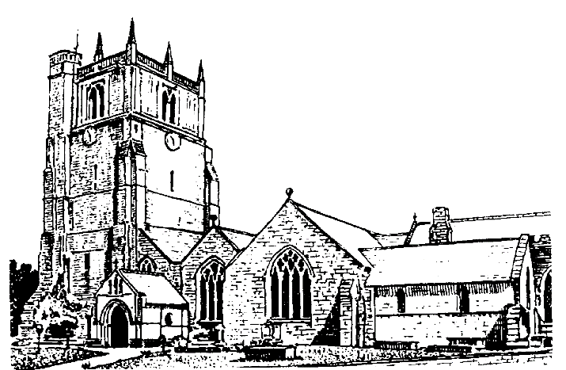

We believe in one God,
Father, Son and Holy Spirit

Welcome to worship at St. Oswald’s. Please introduce yourself, especially if you are a visitor or newcomer.

09.30 Holy Communion at Christ Church Rhydycroesau
President: Fr. Phil Hughes

10.10 Prayers in St. Catherine’s Chapel

10.30 Parish Eucharist at St. Oswald’s

President: Rev. Adrian Bailey

Setting: Shephard - Addington Service

Processional Hymn: 334

The Collect:
Lord, you have taught us that all our doings without love are nothing worth: send your Holy Spirit and pour into our hearts that most excellent gift of love, the true bond of peace and of all virtues, without which whoever lives is counted dead before you. Grant this for your only Son Jesus Christ’s sake, who is alive and reigns with you, in the unity of the Holy Spirit, one God, now and for ever.

Readings: Exodus 19:2-8a
In response to God’s promise and loving care, the Israelites promised to be a holy nation, God’s priests to the whole earth.

Psalm: 116 (v1, 10-17)

Second Reading Romans 5:1-8
God’s almost unbelievable love stretches even to sinners, proved in the redeeming sacrifice of Jesus and the Holy Spirit helping us to grow in faith.

Gradual Hymn: 346

Gospel Matthew 9:35 -10:8 [9-23]
Despite the hardships they might face, Jesus first sends his disciples to the Jewish people, to prove the reality of God’s promise to be with them, by healing and helping.

Preacher: Rev. Adrian Bailey

For your prayers:
For the leaders of the nations that they may seek after ways of peace.
For the people of Iran and other nations in the Middle East and of Sudan.

For our schools, both staff and pupils especially those pupils who are preparing for examinations.

The Church Wardens, PCC, clergy and lay worship teams as they lead us.

For all those working in the caring professions and for those in their charge.

The families and friends of Lance Whitehead, Evelyn Anne Wright, George Roberts Jones, Robert McGrath, George Walter Evans, Louisa Jane Critchell and everyone who has recently been bereaved.

Offertory Hymn: 336
Communion Hymn: 431

Anthem: Let all the World in every Corner Sing - Vaughan Williams

The Post Communion Prayer:
Loving Father, we thank you for feeding us at the supper of your Son; Sustain us with your Spirit, that we may serve you here on earth until our joy is complete in heaven, and we share in the eternal banquet with Jesus Christ our Lord.

Recessional Hymn: 478
Organ Voluntary: Bohm Prelude and fugue in C

Please join us for Coffee in the Parish Centre after the service today.

12.30: Baptism - Jude Norfolk
President: Rev. Adrian Bailey

6 p.m. Evening Prayer
Jenifer Chippett Williams - Commissioned Lay Minister
SUNDAY 21st June (Third after Trinity)
08.00: Holy Communion
President: Fr. Phil Hughes
10.30 Parish Eucharist at St. Oswald’s
President: Fr. Phil Hughes
Preacher: Rev. Dr. Keith Musson
Setting: Macmillan - S. Anne’s Mass
Psalm: 69 (v8-11, 18-20)
Anthem: A New Song - MacMillan
Hymns: 197 (*v 3,5,7) 393, 440 (*v4,5,6) 353,
408.
Choral Evensong - Jenifer Chippett Williams - Commissioned Lay Minister.
Holy is the true light - Harris Psalm: 46
Canticles: Brewer in D Responses Leighton
Anthem: Solus advictimam - Leighton
Hymns: 338 (*v 3,6) 378, 439 (*v 3,4)

