Oswestry School Choristers Music Scholarships
Information Sheet

Oswestry School is now offering chorister scholarships in St. Oswald’s Choir.

This is an opportunity normally only available to choristers of cathedral and collegiate churches and offers young people the chance to combine the fine education available at Oswestry School with the experience of singing to cathedral standard in one of the finest church choirs in the diocese.

Oswestry School Choristers will receive a very generous remission on tuition fees at Oswestry School. There will be extras (charged in arrears) for e.g. trips and other activities (£100 per term might be sensibly budgeted) and uniform (c. £250 one off).

Oswestry School has enjoyed a long and strong relationship with St Oswald’s Church and its choir. The School was founded (in 1407), and the original building still exists, in the churchyard of St Oswald’s.

Director of Music, Mike Donkin, said ”St Oswald’s is the host venue for many of the School’s major celebratory events. Oswestry School has a strong musical tradition and intends to build this further. These scholarships are intended to both cement the relationship between the School and church and enable the fine musicians of the St Oswald’s Church Choir to enjoy an Oswestry School education.”

Application for a Scholarship is open to boys and girls aged between 10 and 13 years of age. The main considerations will be the chorister’s suitability to represent the Church; ability to contribute to the broad musical activity of the School; and likelihood to benefit from the experience. Applicants will expect to serve the Church choir to the best of his/her ability and contribute fully to the musical activity of the School.

The scholarship is awarded for the duration of a pupil’s schooling, provided that the scholarship conditions are met. There is an annual review of all scholarships before Easter of each year. St Oswald’s choristers will be expected to continue to serve in St Oswald’s choir excepting breaks permitted by the choirmaster, for e.g. periods of voice change, or by agreement with the Headmaster.

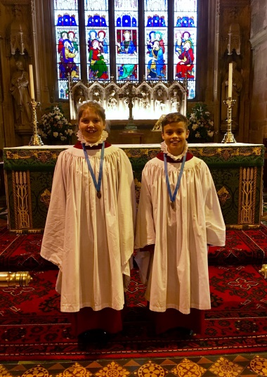

Alice Williams and Myles Wilkinson
St. Oswald’s first Oswestry School Choristers

The level of commitment required by the Church Choir for Oswestry School Choristers is set out below:-

Attendance at Choir Rehearsals which are:
- For Juniors only - Wednesdays 5.45pm to 7.00pm
- With the full choir - Fridays 7.15pm to 8.30pm.
- Voice for Life voice training sessions. These usually last for 1 hour and are currently held prior to Wednesday afternoon rehearsals or Saturday mornings.

Attendance at services which are:
- Every Sunday morning - pre-service practice 9.30am / service 10.30am – 11.40am (approx.).
- Sunday evening services (usually only the 2nd Sunday of the month for choristers although on special occasions there may be more and this commitment increases once the chorister becomes a Choral Scholar, usually after attaining the Bronze Award of the Royal School of Church Music) pre-service practice 5.15pm / service 6.30pm – 7.40pm (approx.).

There are three carol services each year:
- Advent Carol Service on the First Sunday of Advent (Rehearsal 4.00pm, Tea 5.30pm, Service 6.30pm end 7.30pm).
- Nine Lessons & Carols on the Fourth Sunday of Advent (Rehearsal 3.30pm, Tea 5.30pm, Service 6.30pm end 8.00pm).
- Epiphany Carol Service on the First Sunday of Epiphany (Rehearsal 4.00pm, Tea 5.30pm, Service 6.30pm end 7.30pm).

Additionally choristers are required for Ash Wednesday evening, The Christingle Service at 5.00pm on the Third Sunday of Advent and Christmas Day Morning. Choral Scholars are also called for Maundy Thursday, Holy Saturday and Christmas Midnight Mass.

Auditions are held in January of each year and anyone interested in taking up a scholarship should contact Mr Donkin at:-

Hendre House,
Llanfechain,
Powys SY22 6XD
Tel: 01691 649933
e-mail: mvdonkin@aol.com (please put Oswestry School Choristers in the title line.)

