NEWS

Material for the September magazine required TODAY 16th August. Could all organisations and groups in the churches please try to send news by email to dianedawson15@gmail.com.

CHURCH CAR PARK
If you are ‘able’ please leave space for those who are less ‘able’

PLACE OF WELCOME Tuesdays at 10.30 - 12.30 in the Parish Centre.

FOOD BANK: Urgently requires tinned ham/spam/corned beef, tinned tuna and sardines, biscuits and treats, cereal, shampoo and shower Gel, size 5 and 7 nappies and wet dog food.

RIDE AND STRIDE is on 12th September this year. Sponsor forms are at the back of the church, or ask annepilsbury@gmail.com. If Riding and Striding is not for you, PLEASE SPONSOR US! We will be visiting some Shropshire churches by car and trying their cakes, if any! Half the money collected goes to Shropshire Historic Churches Trust, who give grants to churches for repairs and improvements. The other half comes back to St Oswald's. Details on our website, or Google:-Shropshire Historic Churches Trust, Ride and Stride.

stoswald.office@gmail.com
http://www.stoswaldsoswestry.org.uk
follow us on Facebook at:
www.facebook.com/stoswaldsoswestry

CHURCH CALENDAR
MONDAY 17th AUGUST

TUESDAY 18th AUGUST

10.30 Place of Welcome in Parish Centre –

WEDNESDAY 19th AUGUST

09.00 Morning Prayer (online)
10.00 Under 5’s Playgroup - Parish Centre
Work on the Piano

THURSDAY 20th AUGUST

10.30 Holy Communion BCP
19.30 Bell ringing practice - 2100

FRIDAY 21st AUGUST

09.00 Morning Prayer (online)

SATURDAY 22nd AUGUST

Sunday worship on the You Tube page
9 o’clock Morning Prayer is streamed on the Facebook page on Wednesday and Friday

THE PARISH CHURCH OF
ST. OSWALD
KING & MARTYR

ELEVENTH SUNDAY AFTER TRINITY
16TH AUGUST

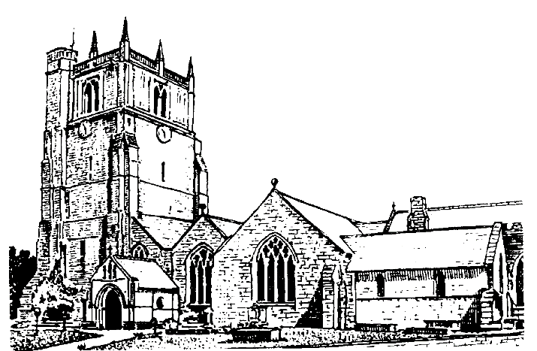

We believe in one God,
Father, Son and Holy Spirit

Welcome to worship at St. Oswald’s. Please introduce yourself, especially if you are a visitor or newcomer.

08.00 Holy Communion at St. Oswald’s
President: Fr. Phil Hughes

10.10 Prayers in St. Catherine’s Chapel

10.30 Parish Eucharist at St. Oswald’s
President: Fr. Phil Hughes

Setting: Shephard - Addington Service

Processional Hymn: 374

The Collect:
O God, you declare your almighty power most chiefly in showing mercy and pity: mercifully grant to us such a measure of your grace, that we, running the way of your commandments, may receive your gracious promises, and be made partakers of your heavenly treasure; through Jesus Christ your Son our Lord, who is alive and reigns with you, in the unity of the Holy Spirit, one God, now and for ever.

Readings - Isaiah 56:1. 6-8
Looking ahead to the restoration of Jerusalem after the exile, the prophet anticipates God’s salvation extending beyond the people of Israel to all people.

Romans 11:1-2a. 29-32
Paul explains that God will never reject God’s own people but has used their disobedience to bring everyone into the universal plan of salvation.

Gradual Hymn: 379

Gospel Matthew 15:[10-20] 21-28
The Gospel reading is an exploration of who and what is acceptable to God, challenging Jesus’ hearers in earthy illustrations and harsh words that can sound shocking to our ears.

Preacher: Fr. Phil Hughes

For your prayers: For the leaders of the nations that they may seek after ways of peace.

For the people of Iran and other nations in the Middle East and of Sudan.

The victims of the earth quakes in Venezuela and Colombia.
Our young people who are making important choices about their future studies and their possible employment and those who advise them.

The Church Wardens, PCC, clergy and lay worship teams as they lead us.

For all those working in the caring professions and for those in their charge.

The families and friends of Margaret Stokes, Peter Davies, Chris Griffiths and everyone who has recently been bereaved.

Offertory Hymn: 391

Communion Hymn: 296

The Post Communion Prayer:
Lord of all mercy, we your faithful people have celebrated that one true sacrifice which takes away our sins and brings pardon and peace: by our communion keep us firm on the foundation of the gospel and preserve us from all sin; through Jesus Christ our Lord.

Recessional Hymn: 377

Please join us for Coffee in the Parish Centre after the service today.

6.00 p.m. Evening Prayer
Mrs. Jenifer Chippett Williams -
Commissioned Lay Minister

SUNDAY 23rd August (Twelfth Sunday after Trinity)
09.30 Holy Communion at Christ Church Rhydycroesau
President: Rev. Dr. Keith Musson

10.30 Parish Eucharist
President: Fr. Phil Hughes
Preacher: Rev. Dr. Keith Musson
Setting: Shephard - Addington Service
Hymns: 385, 395, 397, 307, 408

12.30 Baptism Rebel Rose Carter
President: Rev. Adrian Bailey

6.00 p.m. Reflective Time
Mrs. Lindsay Clarke
Commissioned Lay Minister

