NEWS

There will be a bucket collection on Sunday after the 10.30 a.m. service for Venezuela appeal.

PLACE OF WELCOME Tuesdays at 10.30 - 12.30 in the Parish Centre.

Organ Recital in Church in memory of our past Organist Veronica Donkin by Jamie Rogers, Organist and Assistant Director of Music at Canterbury Cathedral on Saturday 25th July at 1800. Free admission retiring collection for the maintenance and restoration of our historic Hill Organ.

PATRONAL FESTIVAL - Sunday August 2nd from 12.30 p.m. in the Parish Centre. Please indicate on the sheet at the back of church if you are able to attend and what food you can contribute. Please come and enjoy one another’s company. All are welcome.

FOOD BANK: Urgently requires tinned ham/spam/corned beef, tinned tuna and sardines, biscuits and treats, cereal, shampoo and shower Gel, size 5 and 7 nappies and wet dog food.

Saturday 1st August 2026 Orthodox Service in St. Oswalds 10 a.m. and then walk to St. Oswald’s well for blessing and return to the Parish Centre for a talk and refreshments at 12.15. All welcome.

stoswald.office@gmail.com
http://www.stoswaldsoswestry.org.uk
follow us on Facebook at:
www.facebook.com/stoswaldsoswestry

CHURCH CALENDAR
MONDAY 20th JULY

Organ Tuning

TUESDAY 21st JULY

10.30 Place of Welcome in Parish Centre - 12.30

WEDNESDAY 22nd JULY

09.00 Morning Prayer (online)
10.00 Under 5’s Playgroup - Parish Centre
17.15 Brownies in the Parish Centre - 19.15

THURSDAY 23rd JULY

10.30 Holy Communion BCP
19.30 Bell ringing practice - 2100

FRIDAY 24th JULY

09.00 Morning Prayer (online)
19.00 Full Choir - 20.30 in Church
20.30 Choral Scholars and Adults - 21.00

SATURDAY 25th
18.00 Organ Recital in Church in memory of our
past Organist Veronica Donkin by Jamie
Rogers Organist and Assistant Director of
Music at Canterbury Cathedral.

Sunday worship on the You Tube page
9 o’clock Morning Prayer is streamed on the Facebook page on Wednesday and Friday

THE PARISH CHURCH OF
ST. OSWALD
KING & MARTYR

SEVENTH SUNDAY AFTER TRINITY
19TH JULY 2026

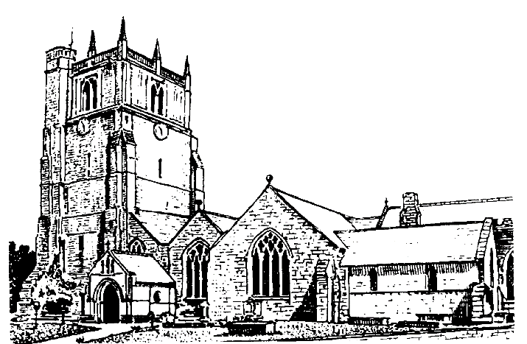

We believe in one God,
Father, Son and Holy Spirit

Welcome to worship at St. Oswald’s. Please introduce yourself, especially if you are a visitor or newcomer.

08.00 Holy Communion
President: Fr. Phil Hughes

10.10 Prayers in St. Catherine’s Chapel

10.30 Parish Eucharist at St. Oswald’s
(St. Oswald’s Singers)

President Fr. Phil Hughes

Setting: Shepherd Addington Service

Processional Hymn: 52

The Collect:
Lord of all power and might, the author and giver of all good things: graft in our hearts the love of your name, increase in us true religion, nourish us with all goodness and of your great mercy keep us in the same; through Jesus Christ your Son our Lord, who is alive and reigns with you, in the unity of the Holy Spirit, one God, now and for ever.

Readings Wisdom of Solomon 12:13. 16-19
This comes from Jewish writings between the Hebrew scriptures and the New Testament, and the writer is exploring the nature of God’s power and interaction with people.

Romans 8:12-25
Paul is speaking about God’s adoption of us, so that we are part of the family of God, not just for us but for the sake of all creation.

Gradual Hymn: 245

Gospel: Matthew 13:24-30. 36-43
One of Jesus’ parables about sowing and harvest.

Preacher: Rev. Dr. Keith Musson

For your prayers:

For the leaders of the nations that they may seek after ways of peace.

For the people of Iran and other nations in the Middle East and of Sudan.

The victims of the earth quake in Venezuela.
Our young people who are making important choices about their future studies and their possible employment and those who advise them.

The Church Wardens, PCC, clergy and lay worship teams as they lead us.

For our young people as they start their summer holidays.

For all those working in the caring professions and for those in their charge.

The families and friends of Bryan Ernest Martin,
John Mellor, Norma Siegrid Hilde Emmi Brannan, Peter Davies, Chris Griffiths and everyone who has recently been bereaved.

Offertory Hymn: 265
Communion Hymn: 341

Anthem: Lead me Lord - Wesley

The Post Communion Prayer:
Lord God, whose Son is the true vine and the source of life, ever giving himself that the world may live: may we so receive within ourselves the power of his death and passion that, in his saving cup, we may share his glory and be made perfect in his love; for he is alive and reigns, now and for ever.

Recessional Hymn: 332

Please join us for Coffee in the Parish Centre after the service today.

6 p.m. Evening Prayer
Commissioned Lay Minister Jenifer Chippett Williams

SUNDAY 26th July (Eighth Sunday after Trinity) (St. Oswald’s Singers)

09.30 Holy Communion at Christ Church Rhydycroesau
President: Fr. Phil Hughes

10.30 Parish Eucharist (St. Oswald’s Singers)
President: Rev. Dr. Keith Musson
Preacher: Rev. Adrian Bailey
Setting: Shephard - Addington
Anthem: O worship the Lord - J Travers
Hymns: 449, 357, 434, 276.235
12.30 Baptism Ezre Griffiths
President: Rev. Adrian Bailey
18.00 Reflective Space
Lindsay Clarke - Commissioned Lay Minister

