NEWS

PLACE OF WELCOME Tuesdays at 10.30 - 12.30 in the Parish Centre. Everyone is welcome.

FOOD BANK: Urgently requires tinned ham/spam/corned beef, tinned fish, jams and spreads, cereal, tomato sauce and mayonnaise, pasta and rice 500g.

SUNDAY 9TH – REMEMBRANCE SUNDAY - to enable the congregation to join the Act of Remembrance at the Park Gates from 10.50 am, there will be a said Eucharist at 9.30 am in church. Coffee will not be served in church after the service. There is a service of commemoration in church at 4.00 pm.

ST OSWALD’S LADIES GROUP meet in the Parish Centre on Monday 3rd November at 2.30 pm. when we welcome Hannah from Pollen Pantry who will demonstrate Wreath Making.

PRAYING FOR OUR WORLD - in the reading area on Wednesday 5th November at 7 pm.

ST OSWALD’ BOOK CLUB meet in Parish Centre on Wednesday 5th November at 7.30 pm. reading ‘Five for Sorrow, Ten for Joy’ meditations on the rosary, by J Neville Ward. All are welcome to come along to discuss the book over coffee and tea.

MOTHERS UNION FELLOWSHIP GROUP meet in the Parish Centre on Thursday 13th November at 14.15. Speaker Kate Donkin. All welcome.

The Rev Harvey Gibbons
stoswald.office@gmail.com
http://www.stoswaldsoswestry.org.uk
or follow us on Facebook at:
www.facebook.com/stoswaldsoswestry
CHURCH CALENDAR

MONDAY 3rd NOVEMBER
10.00 Clergy Eucharist and Meeting
14.30 Ladies Group meet in the Parish Centre -
Speaker Hannah from Pollen Pantry
19.00 Pilgrim Course

TUESDAY 4th NOVEMBER
10.30 Place of Welcome in Parish Centre -12.30
19.15 Oswestry Deanery Synod in Parish Centre
19.30 Cantiones Choir Rehearsal in Church

WEDNESDAY 5th NOVEMBER
08.30 Oswestry School Assembly - 0940
09.00 Morning Prayer (online)
10.00 Under 5’s ‘Stay and Play’ Parish Centre
17.15 Girl Guides/ Brownies in Parish Centre
19.00 Praying for our World in church
19.30 St. Oswald’s Book Club in Parish Centre

THURSDAY 6th NOVEMBER
10.30 Holy Communion (BCP)
12.00 Funeral of Edward Russell Jones
with interment at Oswestry Cemetery
19.30 Bell ringing practice - 2100

FRIDAY 7th NOVEMBER
09.00 Morning Prayer (online)
10.00 Under 5’s Playgroup - Parish Centre
14.30 Act of Remembrance by school children
in Oswestry Cemetery
19.15 Full Choir - 20.30
20.30 Choral Scholars and Adults - 21.00

SATURDAY 8th NOVEMBER
15.30 Cantiones Concert - Duruflé: Requiem in
Church

9 o’clock Morning Prayer is streamed on the Facebook page on Wednesday and Friday mornings. Sunday worship on the You Tube page
THE PARISH CHURCH OF
ST. OSWALD
KING & MARTYR

ALL SAINTS and All SOULS DAY
2nd NOVEMBER 2025

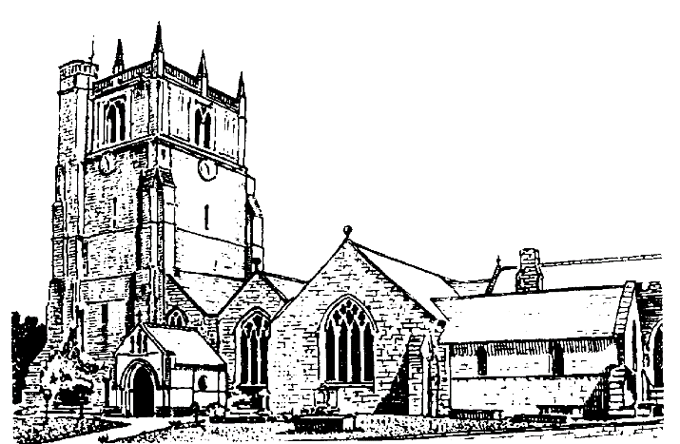

Lord of all life and power, who through the mighty resurrection of your Son overcame the old order of sin and death to make all things new in him: grant that we, being dead to sin and alive to you in Jesus Christ, may reign with him in glory: to whom with you and the Holy Spirit be praise and honour, glory and might now and in all eternity. Amen

Welcome to worship at St. Oswald’s. Please introduce yourself, especially if you are a visitor or newcomer.

08.00 Holy Communion
President: Fr. Phil Hughes

10.10 Prayers in St. Catherine’s Chapel. Everyone welcome.

10.30 Parish Eucharist for All Saints
President: Rev. Harvey Gibbons

Setting: Archer - St. Albans Service

Processional Hymn: 476

The Collect:
Almighty God, you have knit together your elect in one communion and fellowship in the mystical body of your Son Christ our Lord: grant us grace so to follow your blessed saints in all virtuous and godly living that we may come to those inexpressible joys that you have prepared for those who truly love you; through Jesus Christ your Son our Lord, who is alive and reigns with you, in the unity of the Holy Spirit, one God, now and for ever.

Readings:
Daniel 7:1-3.15-18
Whatever may happen in human history, God’s people will have a place in God’s kingdom.

Psalm: 100

Ephesians: 1:11-end
As God’s own people through Christ, we have a glorious and eternal inheritance.

Gradual Hymn: 396

Gospel Luke 6:20-31
Jesus sets out the values that characterise God’s kingdom. Those who are poor, hungry, weeping and hated will experience a reversal of fortune, as will those who are rich, well fed and spoken well of. He finishes with an exhortation to “do to others as you would have them do to you”.

Preacher: Fr. Phil Hughes

For your prayers:

Those working to preserve the ceasefire between Israel and Hamas and those working towards peace between Ukraine and Russia. Those killed and injured, for all who in bereavement, disability and pain continue to suffer the consequences of war and all who promote peace.

The people of Jamaica as they deal with the aftermath of Hurricane Melissa.

The sick and everyone involved in the medical professions, especially those working for the NHS and in residential and care homes.

The families and friends of Edward Russell Jones and everyone who has recently been bereaved.

Offertory Hymn: 197

Communion Hymn: 341

Anthem: O quam gloriosum - Toma Luis de Victoria

The Post Communion Prayer:
God, the source of all holiness and giver of all good things: may we who have shared at this table as strangers and pilgrims here on earth be welcomed with all your saints to the heavenly feast on the day of your kingdom; through Jesus Christ our Lord.

Recessional Hymn: 478

Organ Voluntary: Allegro from Handel’s organ concerto in F major.

Please join us for Coffee in the Parish Centre after the service today.

16.00: All Souls Service of Remembrance
President: Rev. Harvey Gibbons

SUNDAY 9th November – Remembrance Sunday

09.30 Holy Communion at Christ Church Rhydycroesau
President: Fr. Phil Hughes

09.30 Holy Communion (Said) St. Oswalds
President: Rev. Keith Musson
Preacher: Rev Harvey Gibbons

10.50 Act of Remembrance at Cae Glas gates

16.00 Civic Commemoration in Church
President: Rev. Harvey Gibbons

CHARITY CHRISTMAS CARDS POP-UP SHOP OPEN IN CHURCH DAILY 10 A.M. TO 3 P.M. (EXCLUDING SUNDAYS) UNTIL 6TH DECEMBER

