NEWS

THE DEDICATION OF THE ANDREW HARRIS TRAINING SUITE HAS BEEN POSTPONED.

CHURCH CAR PARK
If you are ‘able’ please leave space for those who are less ‘able’

PLACE OF WELCOME Tuesdays at 10.30 - 12.30 in the Parish Centre.

FOOD BANK: Urgently requires tinned ham/spam/corned beef, tinned tuna and sardines, biscuits and treats, cereal, shampoo and shower Gel, size 5 and 7 nappies and wet dog food.

MOTHERS’ UNION FELLOWSHIP GROUP
There will be no meeting in the Parish Centre in August as we have been invited to Welsh Frankton to a service to celebrate 150 years of Mothers’ Union at St. Andrews Church on Tuesday 11th August at 2.30 p.m.

stoswald.office@gmail.com
http://www.stoswaldsoswestry.org.uk
follow us on Facebook at:
www.facebook.com/stoswaldsoswestry

CHURCH CALENDAR
MONDAY 3rd AUGUST

10.00 Clergy Eucharist and Meeting

TUESDAY 4th AUGUST

10.30 Place of Welcome in Parish Centre - 12.30

WEDNESDAY 5th AUGUST

09.00 Morning Prayer (online)
10.00 Under 5’s Playgroup - Parish Centre
19.00 Praying for our world - Reading Area

THURSDAY 6th AUGUST

10.30 Holy Communion BCP
19.30 Bell ringing practice - 2100

FRIDAY 7th AUGUST

09.00 Morning Prayer (online)

SATURDAY 8th AUGUST

Organ Repairs

Sunday worship on the You Tube page
9 o’clock Morning Prayer is streamed on the Facebook page on Wednesday and Friday

THE PARISH CHURCH OF
ST. OSWALD
KING & MARTYR

NINTH SUNDAY AFTER TRINITY
PATRONAL FESTIVAL
ST. OSWALD, KING AND MARTYR
2ND AUGUST

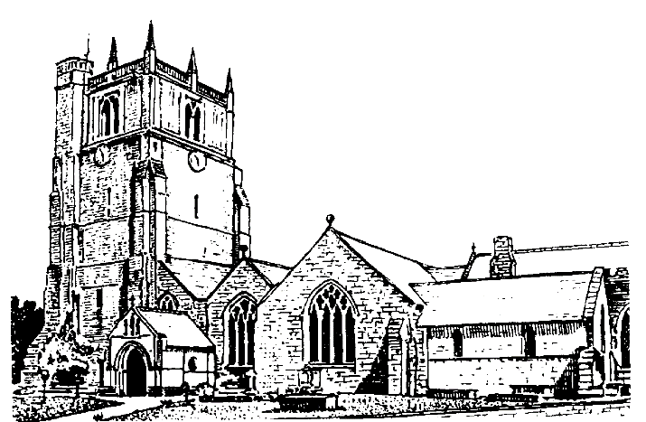

We believe in one God,
Father, Son and Holy Spirit

Welcome to worship at St. Oswald’s. Please introduce yourself, especially if you are a visitor or newcomer.

0800 Holy Communion at St. Oswalds
President: Rev. Adrian Bailey

10.10 Prayers in St. Catherine’s Chapel

10.30 Parish Eucharist at St. Oswald’s
President Rev. Dr. Keith Musson

Setting: Stopford - St. Patricks Eucharist

Processional Hymn: 478

The Collect:
Lord God Almighty who so kindled the faith of King Oswald with your spirit that he set up the sign of the cross in his kingdom and turned his people to the light of Christ: grant that we being fired by the same spirit, may always bear our cross before the world and be founded faithful servants of the Gospel through Jesus Christ your son our Lord who is alive and reigns with you, in the unity of the Holy Spirit, one God now and forever

Readings Isaiah 55:1-5
God invites everyone who thirsts to come to the waters, and those with no money to share wine and milk for free. God promises an everlasting covenant with David, drawing in all the nations.

Psalm145 (v8-9, 15-end)

Romans 9:1-5
Paul laments for his Jewish kindred, to whom belong God’s covenant. Longing for them to believe, Paul wishes he were cut off from Christ for their sake.

Gradual Hymn: 368

Gospel: Matthew 14:13-21
Jesus withdraws from the crowd in a boat, but the five thousand men, together with women and children, follow him on foot. Jesus provides for all their needs, healing the sick and feeding them miraculously with only five loaves and two fishes.

Preacher: Fr. Phil Hughes

For your prayers:
For the leaders of the nations that they may seek after ways of peace.

For the people of Iran and other nations in the Middle East and of Sudan.

The victims of the earth quake in Venezuela.
Our young people who are making important choices about their future studies and their possible employment and those who advise them.

The Church Wardens, PCC, clergy and lay worship teams as they lead us.

For all those working in the caring professions and for those in their charge.

The families and friends of Bryan Ernest Martin,
John Mellor, Peter Davies, Chris Griffiths and everyone who has recently been bereaved.

Offertory Hymn: 373
Communion Hymn: 306
Anthem: Do not be afraid - Stopford

The Post Communion Prayer:
Eternal God, who gave us this holy meal in which we have celebrated the glory of the cross and the victory of your martyr Oswald: by our Communion with Christ in his saving death and resurrection give us with all your saints the courage to conquer evil and so to share the fruit of the tree of life; through Jesus Christ our Lord.

Recessional Hymn: 395
Organ Voluntary: Toccata By George Mushell

There will be no coffee today in the Parish Centre as the centre will be required for preparing the food for the Patronal Festival.

18.00 Choral Evensong
Mrs. Jennifer Chippett Williams - Commissioned Lay Minister
Introit: Beati mundo corde - Ives
Psalm: 80 (v1-8)
Canticles: Roth - Hatfield Service
Responses: Smith Anthem: Faire is the Heaven
Hymns: 443, 357, 186

SUNDAY 9th August (Tenth Sunday after Trinity)
09.30 Holy Communion at Christ Church Rhydycroesau
President: Fr. Phil Hughes
10.30 Parish Eucharist
President: Rev. Adrian Bailey
Preacher: Rev. Dr. Keith Musson
6.00 p.m. Evening Prayer
President: Mrs. Jennifer Chippett Williams
Commissioned Lay Minister

