**NEWS**

**PLACE OF WELCOME** Tuesdays at 10.30 - 12.30 in the Parish Centre. Everyone is welcome.

**FOOD BANK:** Urgently requires tinned ham/spam/corned beef, tea, tinned soup, vegetarian tinned food, size 6-7 nappies and pull ups, cat food and deodorant.

**ALL SOULS** - If you would like a loved one included on the wall of remembrance please add their details on the slips provided in the south aisle.

**CHARITY CHRISTMAS CARDS** - a POP-UP Shop in Church will open to sell Christmas cards & Goods on Behalf of Local and National Charities from Monday 27th October to Saturday 6th December 10 a.m. to 3 p.m. (excluding Sundays)

We will be trying a new format on Remembrance Sunday to enable the choir and congregation to also join the Act of Remembrance at the Park Gates from 10.50 a.m. There will be a said Eucharist at 9.30 a.m. in church that morning but. no coffee will be served in church after the service

Civic Service in the Church at 4.00 pm.

**ST OSWALD’S LADIES GROU**P meet in the Parish Centre on Monday 3rd November at 2.30 p.m. when we welcome Hannah from Pollen Pantry who will demonstrate Wreath Making.

Praying for our World in St. George’s Chapel on Wednesday 5th November at 7 p.m.

**The Rev Harvey Gibbons**

**stoswald.office@gmail.com**

[**http://www.stoswaldsoswestry.org.uk**](http://stoswaldsoswestry.org.uk/)

**or follow us on Facebook at:**

[**www.facebook.com/stoswaldsoswestry**](http://www.facebook.com/stoswaldsoswestry)

***CHURCH CALENDAR***

**MONDAY 27th OCTOBER**

**CHARITY CHRISTMAS CARDS POP-UP SHOP OPENS EVERY DAY 10 A.M. TO 3 P.M.**

**(EXCLUDING SUNDAYS) FROM TODAY UNTIL 6TH DECEMBER**

19.00 There is no Pilgrim Study group tonight

**TUESDAY 28th OCTOBER**

10.30 Place of Welcome in Parish Centre -

12.30

**WEDNESDAY 29th OCTOBER**

09.00 Morning Prayer (online)

10.00 Under 5’s ‘Stay and Play’ Parish Centre

17.15 Girl Guides/ Brownies in Parish Centre

**THURSDAY 30th OCTOBER**

10.30 Holy Communion (BCP)

19.30 Bell ringing practice - 2100

**FRIDAY 31st OCTOBER**

09.00 Morning Prayer (online)

10.00 Under 5’s Playgroup - Parish Centre

19.15 Full Choir - 20.30

20.30 Choral Scholars and Adults - 21.00

**SATURDAY 01st NOVEMBER**

15.15 Bellringers from Beeston

9 o*’clock Morning Prayer is streamed on the Facebook page on Wednesday and Friday mornings. Sunday worship on the You Tube page*

***THE PARISH CHURCH OF***

***ST. OSWALD***

***KING & MARTYR***

**EIGHTEENTH SUNDAY**

**AFTER TRINITY**

**BIBLE SUNDAY**

**26th OCTOBER 2025**

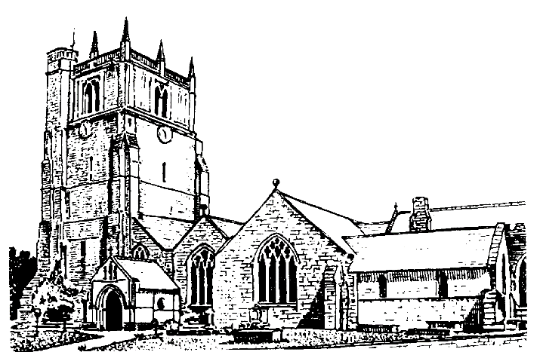

Lord of all life and power, who through the mighty resurrection of your Son overcame the old order of sin and death to make all things new in him: grant that we, being dead to sin and alive to you in Jesus Christ, may reign with him in glory: to whom with you and the Holy Spirit be praise and honour, glory and might now and in all eternity. Amen

Welcome to worship at St. Oswald’s. Please introduce yourself, especially if you are a visitor or newcomer.

**09.30 Holy Communion at Christ Church Rhydycroesau**

President: Rev. Harvey Gibbons

**10.10 Prayers in St. Catherine’s Chapel. Everyone welcome.**

**10.30 Parish Eucharist** *(St. Oswald’s Singers)*

President: Rev. Keith Musson

Setting: Shephard - Addington Service

Processional Hymn: 473 (omit * verses)

**The Collect:**

Blessed Lord, who caused all holy scriptures to be written for our learning: help us so to hear them, to read, mark, learn and inwardly digest them that, through patience and the comfort of your holy word, we may embrace and for ever hold fast the hope of everlasting life, which you have given us in our Saviour Jesus Christ, who is alive and reigns with you, in the unity of the Holy Spirit, one God now and for ever.

**Readings: Isaiah 45:22-end**

God’s word is more than a promise or an oath – it is the creative and saving power of the universe, the strength of those who believe.

**Romans 15: 1-6**

The written words of scripture can provide guidance in our dealings with others and be a source of hope.

Gradual Hymn: 370

**Gospel** Luke 4:16-24

The Nazareth congregation appreciated the spoken words of Jesus but could not believe that somebody who had grown up among them could fulfil the written words of scripture.

**Preacher**: Rev. Keith Musson

**For your prayers:**

Family and friends of Florence Gray Swannick being baptised here this morning.

Those working to secure a ceasefire between Ukraine and Russia, and Israel and Hamas. Those killed and injured, for all who in bereavement, disability and pain continue to suffer the consequences of war and all who promote peace.

The staff and young people of our local schools as they begin their half term break.

The sick and everyone involved in the medical professions, especially those working for the NHS and in residential and care homes.

The families and friends of Edward Russell Jones and everyone who has recently been bereaved.

Offertory Hymn: 407

Communion Hymn: 342

**Anthem:** View me Lord - Lloyd

**The Post Communion Prayer:**

God of all grace, your Son Jesus Christ fed the hungry with the bread of his life and the word of his kingdom: renew your people with your heavenly grace, and in all our weakness sustain us by your true and living bread; who is alive and reigns, now and for ever.

Recessional Hymn: 272

**Organ Voluntary:**  MasterTallis’s Testament - Howells

**Please join us for Coffee in the Parish Centre after the service today.**

12.30: Baptism - Florence Gray Swannick

Rev. Harvey Gibbons

18.00: Reflective Time

Preacher: Rev. Harvey Gibbons

**SUNDAY 2nd November - All Saints and All Souls**

08.00 Holy Communion

President: Fr. Phil Hughes

10.30 Parish Eucharist

President: Rev. Harvey Gibbons

Preacher: Fr. Phil Hugh

16.00 All Souls