**NEWS**

**FOOD BANK:** urgently requires tinned ham/spam/corned beef, small coffee and tea, tinned spaghetti, large tins of sweetcorn, jams and spreads, size 6-7 nappies and pull ups, dog and cat food, shampoo and shower gel.

**PLACE OF WELCOME** 10.30 - 12.30 in the Parish Centre. Everyone is welcome and it is free of charge.

**JASSICA’S LAST SUNDAY** will be May 25th

and her Licensing service in Great Yarmouth is on

15th June at 3pm. Please keep Jassica, Roy and

El-Nathan in your prayers

**THE ANNUAL PAROCHIAL CHURCH MEETING** will be held on 19th May.  The electoral roll without telephone numbers will be displayed on the table by the main (south) door in church until 14thMay for checking.  Please check that your name is shown on the Electoral Roll.  If you have changed your address in the last year please contact Maureen Crosby 01691658606. Details in theMay magazine**.**

One of the initiatives of the Pastoral Care Group is to form the ‘Pudding Club‘ which, we hope, will bring people together to share fun and fayre (namely puddings!). If you would like to find out more and/or offer some further ideas for entertainment, please speak to June who will be in the office on most Friday mornings. Watch out for their first venture on Saturday, 17th May in the Parish Centre starting at 2.30pm.

Haydn Jones will be running the Manchester half marathon on Sunday May 18th for Debra UK

Sponsor form are on the table in the south aisle in Church if you would like to sponsor him.

***CHURCH CALENDAR***

**MONDAY 28th APRIL**

08.30 Oswestry School Assembly - 0940

10.00 Rosemary May Pierpoint interment of

Ashes at Oswestry Cemetery.

19.30 St. Oswald’s Book Club - Parish Centre

**TUESDAY 29th APRIL**

10.30 Place of Welcome in Parish Centre

**WEDNESDAY 30th APRIL**

09.00 Morning Prayer (online)

10.00 Under 5’s ‘Stay and Play’ Parish Centre

17.15 Brownies in Parish Centre - 19.15

**THURSDAY 1st MAY**

10.30 Holy Communion (BCP)

19.30 Bell ringing practice - 2100

**FRIDAY 2nd MAY**

09.00 Morning Prayer (online)

10.00 Under 5’s ‘Stay and Play’ Parish Centre

**SATURDAY 3rd MAY**

09.00 Orthodox Divine Liturgy Service in Church

*All are welcome.*

**The Rev Harvey Gibbons**

**stoswald.office@gmail.com**

[**http://www.stoswaldsoswestry.org.uk**](http://stoswaldsoswestry.org.uk)

**or follow us on Facebook at:**

[**www.facebook.com/stoswaldsoswestry**](http://www.facebook.com/stoswaldsoswestry)

*9 o’clock Morning Prayer is streamed online through the facebook page on Wednesday and Friday morning*

***THE PARISH CHURCH OF***

***ST. OSWALD***

***KING & MARTYR***

**SECOND SUNDAY OF EASTER**

**27th APRIL 2025**

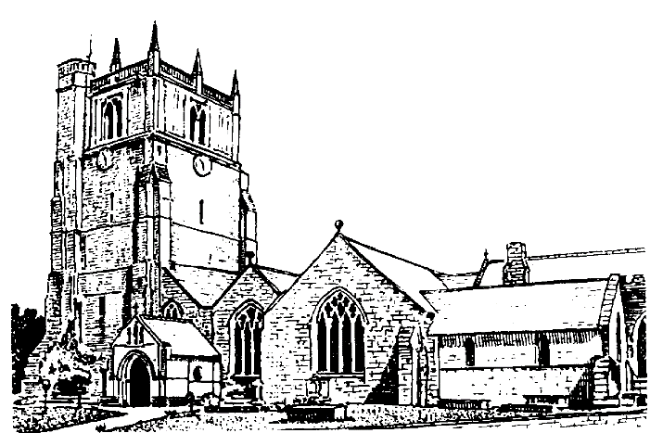

Lord of all life and power, who through the mighty resurrection of your Son overcame the old order of sin and death to make all things new in him: grant that we, being dead to sin and alive to you in Jesus Christ, may reign with him in glory: to whom with you and the Holy Spirit be praise and honour, glory and might now and in all eternity. Amen

Welcome to worship at St. Oswald’s. Please introduce yourself, especially if you are a visitor or newcomer.

10.10 Prayers in St. Catherine’s Chapel

**10.30 Parish Eucharist**

President: Fr. Phil Hughes

Setting: Shephard - Addington Service

Processional Hymn: 107

**The Collect:**

Almighty Father, you have given your only Son to die for our sins and to rise again for our justification: grant us so to put away the leaven of malice and wickedness that we may always serve you in pureness of living and truth; through the merits of your son Jesus Christ our Lord, who is alive and reigns with you, in the unity of the Holy Spirit, one God, now and for ever.

**Readings:**  Exodus 14:10-end; 15:20. 21

Pharaoh’s powerful army is defeated in the Red Sea, while the frightened people of Israel are encouraged and emboldened to cross to dry land.

Acts 5:27-32

Peter and John are brought before the council to answer for their preaching. Peter finds the courage to speak of Jesus’ resurrection and the gift of the Holy Spirit.

Gradual Hymn: 369

**Gospel**

John 20:19-end

Jesus appears to his disciples and breathes his Spirit on them. Thomas, missing on that occasion, has a powerful encounter with his risen Lord a week later.

**Preacher:** Rev. Keith Musson

**For your prayers:**

All who are mourning the death of Pope Francis, those involved in the election of his successor and those who are being considered.

The staff and young people of our schools as they begin a new school term.

Those working to secure a ceasefire between Israel and Hamas, those killed and injured, for all who in bereavement, disability and pain continue to suffer the consequences of the fighting and for all working towards peace.

Those gathering to discuss the terms to end the Ukraine war.

The victims of all forms of abuse especially children and young people and those working to keep them safe from harm.

The sick and everyone involved in the medical professions, especially those working for the NHS and in residential and care homes.

The families and friends of John Roberts, Vera Brunt, Jean Rosemary Roberts, Roger Owen Derwas, Christopher Ellison, Maureen Ross, Kathleen Mabel Hemus and everyone who has recently been bereaved.

Offertory Hymn: 103

Communion Hymn: 118

**Anthem**: Ye sons and daughters of the lord - Walford Davies

**The Post Communion Prayer:**

Lord God our Father, through our Saviour Jesus Christ you have assured your children of eternal life and in baptism have made us one with him: deliver us from the death of sin and raise us to new life in your love, in the fellowship of the Holy Spirit, by the grace of our Lord Jesus Christ.

Recessional hymn: 235

***Please join us for refreshments in the Parish Centre after our service***

**No evening service today**

**SUNDAY 4th MAY** *(Third Sunday of Easter)*

08.00 Holy Communion

10.30 Parish Eucharist

18.00 Evening Prayer