**NEWS**

**FOOD BANK:** Urgently requires tinned ham/spam/corned beef, small coffee and tea, tinned spaghetti large tins of sweetcorn, jam and spreads, size 6-7 nappies and pull ups, dog and cat food, shampoo and shower gel.

**ST. OSWALD’S BOOK CLUB** meet in the Parish Centre Monday 30th June reading ’I heard the Owl Call My Name’ by Margaret Craven.

**10 YEAR ANNIVERSARY CONCERT OF THE CHAMBER CHOIR,** Scholars and Gentlemen, in Church Saturday 5th July at 7.00 p.m. Entry free. Come along and help them celebrate.

**ST OSWALD’S LADIES GROUP** meet in the Parish Centre on Monday 7th July at 2.30 p.m. when we welcome our Speaker - Sarah Gibson.

Shropshire Wildlife Trust’s Communications Officer. ‘Conservation - Swifts and Us’

**MOTHERS’ UNION FELLOWSHIP GROUP** meet in Parish Centre on Thursday 10th July at

14.15 p.m.

Haydn would like to thank everyone who sponsored him for the half marathon run in Manchester. £420 has been sent to the Debra charity.

**The Rev Harvey Gibbons**

**stoswald.office@gmail.com**

[**http://www.stoswaldsoswestry.org.uk**](http://stoswaldsoswestry.org.uk)

**or follow us on Facebook at:**

[**www.facebook.com/stoswaldsoswestry**](http://www.facebook.com/stoswaldsoswestry)

*.*

***CHURCH CALENDAR***

**MONDAY 30th JUNE**

19.30 St. Oswald’s Book Club meet in the Parish

Centre reading ‘I heard the Owl Call My

Name’ by Margaret Craven.

**TUESDAY 1ST JULY**

10.30 Place of Welcome in Parish Centre

**WEDNESDAY 2nd JULY**

14.00 Funeral of Irene Joyce Burtoo followed by

interment at Oswestry Cemetery.

10.00 Under 5’s ‘Stay and Play’ Parish Centre

17.15 Brownies in Parish Centre - 19.15

19.30 Scholars & Gentlemen rehearsal - 21.00

**THURSDAY 3rd JULY**

10.30 Holy Communion (BCP)

14.00 Funeral of Anne Elizabeth Creswell

private

19.30 Bell ringing practice - 2100

**FRIDAY 4th JULY**

09.00 Morning Prayer (online)

10.00 Under 5’s ‘Stay and Play’ Parish Centre

14.00 Oswestry School end of term service in

Church - 4 p.m.

18.45 Junior Choir Rehearsal in Parish Centre

19.15 Full Choir - 20.15

20.15 Choral Scholars & Adults only - 21.00

**SATURDAY 5th JULY**

15.00 Mid Cheshire Bellringers in Tower - 16.15

19.0010 year Anniversary Concert of the

Chamber Choir Scholars and Gentlemen

in Church. Entry free

*9 o’clock Morning Prayer is streamed on the Facebook page on Friday morning. Sunday worship on the You Tube page*

***THE PARISH CHURCH OF***

***ST. OSWALD***

***KING & MARTYR***

**SECOND SUNDAY AFTER TRINITY**

**29TH JUNE 2025**

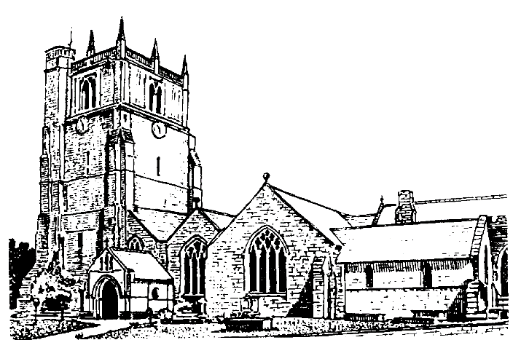

Lord of all life and power, who through the mighty resurrection of your Son overcame the old order of sin and death to make all things new in him: grant that we, being dead to sin and alive to you in Jesus Christ, may reign with him in glory: to whom with you and the Holy Spirit be praise and honour, glory and might now and in all eternity. Amen

Welcome to worship at St. Oswald’s. Please introduce yourself, especially if you are a visitor or newcomer.

10.10 Prayers in St. Catherine’s Chapel

**10.30 Parish Eucharist**

President: Rev. Harvey Gibbons

Setting: Archer - St. Albans Service

Processional Hymn: 225

**The Collect:**

Lord, you have taught us that all our doings without love are nothing worth: send your Holy Spirit and pour into our hearts that most excellent gift of love, the true bond of peace and of all virtues, without which whoever lives is counted dead before you. Grant this for your only Son Jesus Christ’s sake, who is alive and reigns with you, in the unity of the Holy Spirit, one God, now and for ever.

**Readings:**

1 Kings 19:15-16. 19-end

Elijah finds Elisha ploughing. Elijah throws his mantle over him, but Elisha wants to say goodbye to his parents before following him. After eating and feeding the people, Elisha follows Elijah and becomes his servant.

Psalm: 125

Galatians 5:1. 13-25

Paul encourages the Galatians not to submit to slavery because they were born for freedom. They are to live by the Spirit and not the flesh.

Gradual Hymn: 359

**Gospel:** Luke 9: 51-end

The people of a village refuse to accept Jesus, although he rebukes the disciples for suggesting they should call down fire upon it. One would-be follower wants to return home to bury his father, while another wants to say farewell to those at home. Jesus says that no one who looks back is fit for the kingdom of God.

**Preacher**: Rev. Keith Musson

**For your prayers:**

Those working to secure and maintain a ceasefire between Israel and Hamas, Israel and Iran, and Ukraine and Russia. Those killed and injured, for all who in bereavement, disability and pain continue to suffer the consequences of the fighting and for all working towards peace.

The victims of all forms of abuse especially children and young people and those working to keep them safe from harm.

The sick and everyone involved in the medical professions, especially those working for the NHS and in residential and care homes.

The families and friends of Edward George Holmes, Heather Taylor, Patricia Ann Hollywell,

Joan Hallam, Sylvia West, Barbara Stella Stratford Irene Joyce Burtoo, Anne Elizabeth Creswell, John Leonard, Betty Patricia Griffiths and everyone who has recently been bereaved,

Offertory Hymn: 172

Communion Hymn: 213

Anthem: Tu es Petrus - *Hassler*

**The Post Communion Prayer:**

Loving Father, we thank you for feeding us at the supper of your Son: sustain us with your Spirit, that we may serve you here on earth until our joy is complete in heaven, and we share in the eternal banquet with Jesus Christ our Lord.

Recessional Hymn: 215

**Organ Voluntary:**

**Louis James Lefebure-Wely:** Marche (from Meditaciones Religiosas).

***Please join us for refreshments in the Parish Centre after our service.***

**NO SERVICE THIS EVENING**

**SUNDAY 6th JULY** *(Third Sunday after Trinity)*

08.00 Holy Communion

President: Rev. Harvey Gibbons

10.30Parish Eucharist

President: Rev. Keith Musson

12.30 Baptism - Atlas Spaccesi Pau Davies

President: Rev. Harvey Gibbons

18.00 Choral Evensong

Preacher: Rev. Harvey Gibbons