NEWS

EPIPHANY DRINKS ON JANUARY 6th… drop in to the vicarage between 6pm and 8pm for seasonal refreshments. Everyone welcome.

Material required in the office for the February magazine Sunday 11 January. Please could all organisations and groups in the churches try to send some news in or email dianedawson15@gmail.com

PLACE OF WELCOME Tuesdays at 10.30 - 12.30 in the Parish Centre. Everyone is welcome.

FOOD BANK: Urgently requires tinned ham/spam/corned beef, baked beans, spaghetti hoops, tea and coffee, jams and spreads, tomato sauce and mayonnaise, pasta and rice 500g, dog and cat food.

ST. OSWALD’S LADIES GROUP meet in the Parish Centre on Monday 5th January at 2.30 p.m. Guest speaker David Preston.

PRAYING FOR OUR WORLD - The Mission and Ministry Team invite you to join them in prayer in the reading area in Church for their monthly meeting at 7 p.m. on Wednesday 7th January.

MOTHERS’ UNION FELLOWSHIP GROUP meet in the Parish Centre on Thursday 8th January at 2.15 p.m. when we will celebrate our informal Eucharist for the coming year led by Father Phil Hughes.

9 o’clock Morning Prayer is streamed on the Facebook page on Wednesday and Friday
mornings.
Sunday worship on the You Tube page

CHURCH CALENDAR

MONDAY 5th JANUARY
10.00 Clergy Eucharist and Meeting
13.30 Funeral of William Benyon in church
14.30 St. Oswald’s Ladies Group meet in the
Parish Centre - Speaker David Preston

TUESDAY 6th JANUARY
09.15 Oswestry School Assembly - 10.45
10.30 Place of Welcome in Parish Centre
18.00 Epiphany drinks at the Vicarage
between 6 p.m. and 8 p.m. All welcome.

WEDNESDAY 7th JANUARY
09.00 Morning Prayer (online)
10.00 Under 5’s Playgroup - Parish Centre
19.00 Praying for our World in the reading
area in church. All welcome.
19.30 Book Club meet in the Parish Centre
Reading and discussing ‘Praying by
Heart, The Lord’s Prayer for
Everyone’. All welcome.

THURSDAY 8th JANUARY
10.30 Holy Communion (BCP)
14.15 Mothers’ Union fellowship group meet in
the Parish Centre. Informal Eucharist
led by Father Phil.
19.30 Bell ringing practice - 2100

FRIDAY 9th JANUARY
09.00 Morning Prayer (online)
19.15 Full Choir - 20.30
20.30 Choral Scholars and Adults - 21.00

The Rev Harvey Gibbons
stoswald.office@gmail.com
http://www.stoswaldsoswestry.org.uk
or follow us on Facebook at:
www.facebook.com/stoswaldsoswestry

THE PARISH CHURCH OF
ST. OSWALD
KING & MARTYR

EPIPHANY
4th January 2026

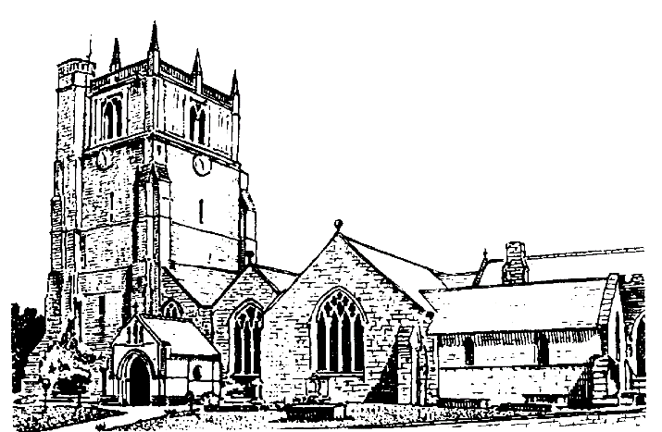

Lord of all life and power, who through the mighty resurrection of your Son overcame the old order of sin and death to make all things new in him: grant that we, being dead to sin and alive to you in Jesus Christ, may reign with him in glory: to whom with you and the Holy Spirit be praise and honour, glory and might now and
in all eternity. Amen

Welcome to worship at St. Oswald’s. Please introduce yourself, especially if you are a visitor or newcomer.

10.10 Prayers in St. Catherine’s Chapel

10.30 Parish Eucharist at St. Oswald’s

President: Fr. Phil Hughes

Setting: Shephard - Addington Service

Processional Hymn: 47

The Collect:
O God, who by the leading of a star manifested your only Son to the peoples of the earth; mercifully grant that we, who know you now by faith, may at last behold your glory face to face; through Jesus Christ your Son our Lord, who is alive and reigns with you, in the unity of the Holy Spirit, one God, now and for ever.

Readings:
Isaiah 60:1-6
The light of the Lord has come and everyone will be drawn to it, bringing the wealth of the nations.

Ephesians 3:1-12
Paul explains that the Gentiles have become fellow heirs and share the promise of Christ. It is through the Church that the wisdom of God will be made known to everyone, including rulers and authorities.

Gradual Hymn 48

Gospel: Matthew 2:1-12
Wise men from the East visit Jesus in Bethlehem, having first made the mistake of going to Jerusalem and asking for him at Herod’s palace. Herod is troubled by the idea of a new king who might supplant him. He asks the wise men to return and tell him when they have found Jesus, but they are warned in a dream to return home a different way.

Preacher: Rev. Adrian Bailey

For your prayers:

Those working to preserve the ceasefire between Israel and Hamas and those working towards peace between Ukraine and Russia.

Everyone working to keep others safe and those for whom Christmas has been a difficult time

The sick and everyone involved in the medical professions, especially those working for the NHS and in residential and care homes.

The families and friends of William Benyon, Lorraine Pashen, Irmgard Willeck and everyone who has recently been bereaved.

Offertory Hymn: 52

Communion Hymn: 51

Anthem: Bread of the World in mercy broken - Bourgeois (arr. Vaughan Williams)

The Post Communion Prayer:
Lord God, the bright splendour whom the nations seek: may we who with the wise men have been drawn by your light discern the glory of your presence in your Son, the Word made flesh, Jesus Christ our Lord.

Recessional Hymn: 55

Organ Voluntary:

Please join us for Coffee in the Parish Centre after the service today.

18.00 Spoken Evening Prayer
Jenifer Chippet-Williams

SUNDAY 11th January (The Baptism of Christ) Epiphany 1

9.30 Christ Church Rhydycroesau
Holy Communion
Rev. Harvey Gibbons

10.30 Parish Eucharist St. Oswalds

18.00 Epiphany Carol Service

Wishing everyone a very happy
and
peaceful New Year

