NEWS
Material for the July magazine required Sunday 14th June. Could all organisations and groups in the churches please try to send news by email to dianedawson15@gmail.com.

PLACE OF WELCOME Tuesdays at 10.30 - 12.30 in the Parish Centre.

Pudding Club are holding a Strawberry Tea in the Parish Centre on Saturday 13th June 3p.m. - 5p.m. with musical entertainment. Tickets £5 from June Williams in church
Anyone attending Anne Wright’s funeral in Church on Monday June 15th at 10 a.m. Please wear bright colours as requested by Anne - No Black!!! Refreshments will follow in the Parish centre after the service
Archdeacon’s visitation - Whittington Church Wednesday 17th June at 18.30 for 19:00

Scholars and Gentleman are giving a concert of Madrigals and Elizabethan Song on 20th June in Church at 7 p.m. in aid of the music at St. Oswald’s. Tickets £12 each (£10 for more than one) on the door or telephone Mike Donkin on 07779917724.
Sunday worship
on the You Tube page
9 o’clock Morning Prayer is streamed on the Facebook page on Wednesday and Friday
stoswald.office@gmail.com
http://www.stoswaldsoswestry.org.uk
or follow us on Facebook at:
www.facebook.com/stoswaldsoswestry

CHURCH CALENDAR
MONDAY 8th JUNE

10.00 Clergy Eucharist and Meeting
19.00 Section 11 Meeting in Parish Centre

TUESDAY 9th JUNE

10.30 Place of Welcome in Parish Centre - 12.30

WEDNESDAY 10th JUNE

09.00 Morning Prayer (online)
10.00 Under 5’s Playgroup - Parish Centre
17.15 Brownies in the Parish Centre - 19.15
19.30 Scholars and Gentlemen rehearsal in
Parish Centre

THURSDAY 11th JUNE

10.30 Holy Communion BCP
19.30 Bell ringing practice - 2100

FRIDAY 12th JUNE

09.00 Morning Prayer (online)
19.00 Full Choir - 20.30 in Church
20.30 Choral Scholars and Adults - 21.00

SATURDAY 13th JUNE

15.00 Pudding Club Strawberry Tea with musical
entertainment in the Parish Centre - 17.00
Tickets from June Williams in church

THE PARISH CHURCH OF
ST. OSWALD
KING & MARTYR

FIRST SUNDAY AFTER TRINITY
7th JUNE 2026

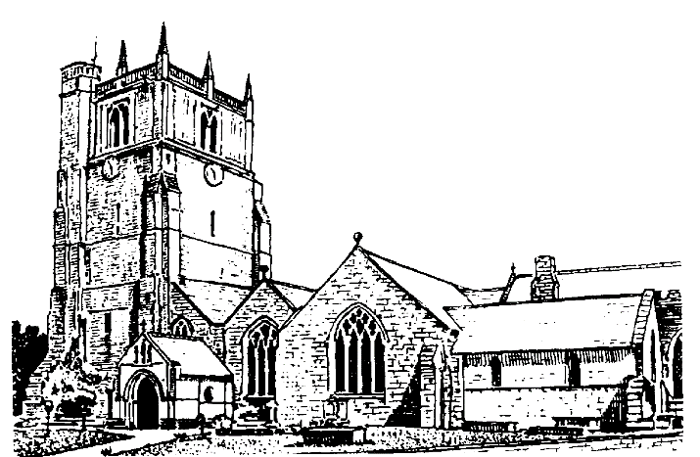

We believe in one God,
Father, Son and Holy Spirit

Welcome to worship at St. Oswald’s. Please introduce yourself, especially if you are a visitor or newcomer.

08.00 Holy Communion at St. Oswald’s
President: Rev. Adrian Bailey

10.10 Prayers in St. Catherine’s Chapel

10.30 Parish Eucharist at St. Oswald’s

President: Fr. Phil Hughes

Setting: Stopford - St. Patrick’s Eucharist

Processional Hymn: NHWS 2

The Collect:
O God, the strength of all those who put their trust in you, mercifully accept our prayers and, because through the weakness of our mortal nature we can do no good thing without you, grant us the help of your grace, that in the keeping of your commandments we may please you both in will and deed; through Jesus Christ your Son our Lord, who is alive and reigns with you, in the unity of the Holy Spirit, one God now and for ever.

Readings: Hosea 5:15 - 6:6

God despairs of the people of Israel because they have made religious observance more important than their relationship with God.

Romans 4:13-end
The key to understanding the story of God’s people, from the call of Abraham onwards, is faith in the God whose promises have found fulfilment in the death and resurrection of Jesus.

Gradual Hymn: NHWS 40

Gospel Matthew 9:9-13. 18-26
Jesus demonstrates his and God’s priorities by eating with unsuitable companions and making himself unclean by performing acts of healing and resurrection.

Preacher: Fr. Phil Hughes

For your prayers:
For the leaders of the nations that they may seek after ways of peace.
For the people of Iran and other nations in the Middle East and of Sudan.

For our schools, both staff and pupils especially those pupils who are preparing for examinations.

The Church Wardens, PCC, clergy and lay worship teams as they lead us.

For all those working in the caring professions and for those in their charge.

The families and friends of Lance Whitehead, Evelyn Anne Wright, George Roberts Jones, Robert McGrath, George Walter Evans, Louisa Jane Critchell and everyone who has recently been bereaved.

Offertory Hymn: NHWS 173

Communion Hymn: NHWS: 12

Anthem: Sent by the Lord am I - Weaver

The Post Communion Prayer:
Eternal Father, we thank you for nourishing us with these heavenly gifts: may our communion strengthen us in faith, build us up in hope, and make us grow in love; for the sake of Jesus Christ our Lord.

Recessional Hymn: NHWS: 166

Organ Voluntary: Postlude on Laura Sion Salvatorem by Pinkevicious.

Please join us for Coffee in the Parish Centre after the service today.

18.00 Choral Evensong
Jenifer Chippett Williams - Commissioned Lay Minister
Introit: Corpus Christi Carol - Benjamin Britten
Psalm: 41 Canticles: Murrill in E Responses Clucas
Anthem: Like as a hart - Howells
Hymns: 338 (*V3,6) 378, 439(*v 3,4)

SUNDAY 14th June (Second Sunday after Trinity)
9.30 a.m. Holy Communion at Christ Church Rhydycroesau
President: Fr. Phil Hughes
10.30 Parish Eucharist at St. Oswald’s
President & Preacher - Rev. Adrian Bailey
12.30 Baptism - Jude Norfolk
6 p.m. Evening Prayer
Jenifer Chippett Williams - Commissioned Lay Minister

